Archaeologies of Knowledge for Data Science:
A Discourse on Art, Archives, and AI

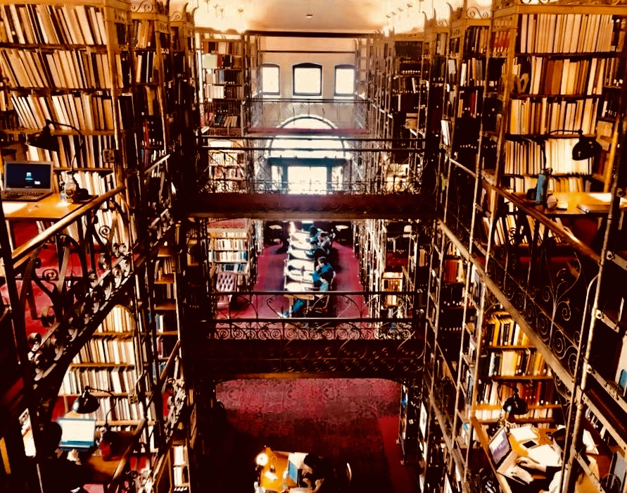

Emily L. Spratt
Department of Art and Archaeology, Princeton University

Abstract:

In the last five years the nature of historical inquiry has undergone a radical transformation as the use of AI-enhanced search engines has become the predominant mode of knowledge investigation. In this system, the discovery of responses to our every question is facilitated as the vast stores of digital information that we have come to call the data universe are conjured to deliver answers commensurate with our human scale of comprehension. In this digital engagement it is often assumed that queries are met with complete and reliable answers, and that data is synonymous with empirical validity, despite the frequently changing structure of this mostly unsupervised repository of digital information, which in actuality projects a distortion of the physical world it represents. In this presentation, the role of vision technology and AI in navigating, analyzing, organizing, and constructing our art and art historical archives will be examined as a shaping force on our interpretation of the past and projection of the future. Drawing upon the observations made by Michel Foucault in The Archaeology of Knowledge that the trends toward continuity and discontinuity in descriptions of historical narratives and philosophy, respectively, are reflections of larger hermeneutic structures that in and of themselves influence knowledge formation, the question of the role of image-related data science in our humanistic interpretation of the world will be explored. Through the examples of preservationists and artists using machine learning techniques to curate and createvisual information, and in consideration of the information management needs of cultural institutions, the machine-learned image will be posited as a new and radical phenomenon of our society that is altering the nature of historical interpretation itself.
Biography:
Emily L. Spratt is a Byzantine and Renaissance–Baroque art historian, art technologist, and strategic advisor. She recently completed a fellowship at The Frick Collection and Art Reference Library consulting and conducting research on art and vision technology, and is finishing her doctorate in the Department of Art and Archaeology at Princeton University with a dissertation on the legacy of Byzantium in the early modern period. Her main areas of specialization include: Venice and the Mediterranean, 1400–1600; the Hellenic world from antiquity to the Greek independence movement; museums and cultural heritage preservation, aesthetic theory, vision technology and machine learning in the arts, ethics and A.I., human-computer interaction, and advisory in the art-tech business sector.
At Princeton University Emily received an M.A. in Renaissance art history and has been a Stanley J. Seeger Fellow in the Program in Hellenic studies and a graduate fellow in the Princeton Institute for International and Regional Studies. She also holds an M.A. in Byzantine art history from UCLA, and a B.A. in religious studies and the history of art with a concentration in psychology from Cornell University.
Emily is a former member of the Art and Artificial Intelligence Laboratory in the Department of Computer Science at Rutgers University. She has also been a visiting lecturer in the Department of the History of Art and the Program in Cultural Heritage and Preservation Studies at Rutgers. With experience at the Byzantine and Christian Museum of Athens, the Benaki Museum, and the former Hellenic Ministry of Culture, Emily has been a collaborator on a number of projects and international exhibitions related to Byzantium. In relation to her research in computer vision science, she curated the pioneering exhibition “Unhuman: Art in the Age of AI,” which featured the art produced by the AICAN algorithm in Los Angeles and Frankfurt in October of 2017, and was showcased on CBS News in a segment on art and AI. At The Frick , Emily organized with her colleagues the blockbuster symposium “Searching Through Seeing: Optimizing Vision Technology for the Arts.” Emily also was the honorary guest editor for the special magazine issue on computers and art for the Association of Computing Machinery.
Emily has been the recipient of numerous fellowships and awards from the Onassis Foundation, the Gladys Krieble Delmas Foundation, the Cini Foundation in Venice, the Cyprus American Archaeological Research Institution, the American Research Center in Sofia, Bulgaria, the Hellenic Ministry of Culture, the Frick Collection and Art Reference Library, and from the universities from where she holds degrees. She is on the digital and multimedia advisory board of the Renaissance Society of America, is a steering-committee member for The Frick Collection and Art Reference Library Scholars' Advisory Group, and is on the advisory board of the Artificial Intelligence Finance Institute (AIFI) of New York City. Emily's insights on art, A.I., and society have been sought in articles and interviews with the Washington Post, CBS News Sunday Morning, Agence France Presse, Chosun Media, Science News, City Press, and other news outlets.


